Work Health and Safety Act 2011 (WHS Act)
Work Health and Safety Regulation (WHS Regulation

Appendix 2: PErforM Risk assessment tool .

Worksheet 1—Manual tasks risk assessment form
PErforM - Participative Ergonomics for Manual Tasks
Manual tasks risk assessment form

Date and Workplace
Date: Workplace:

Risk assessors
Work unit / team:
Positions:
Names:

Task description
Name of task
Why was this task selected?
Locations where this task occurs:
Who performs the task?
General description of the task:

Postures:

Forceful/muscular exertions:

Repetition and duration:

Tools or equipment used:

Work task organisation and environment:

Worksheet 2—Risk factor assessment .
- Indicate on the body chart which area(s) of the body you feel are affected by the task.
- If more than one body part is affected, you may shade the different body parts in different colours. If so, use the matching colour when scoring the risk factors (e.g. red for arms on the body and score sheet, blue for low back on the body and score sheet).
- Give each risk factor a score out of five. One (1) is when the risk factor is not present and five (5) is when the risk factor is the most severe level they have experienced.

Exertion - How much force is the person using?  - Think about starting or stopping quickly |  |  |  |  | 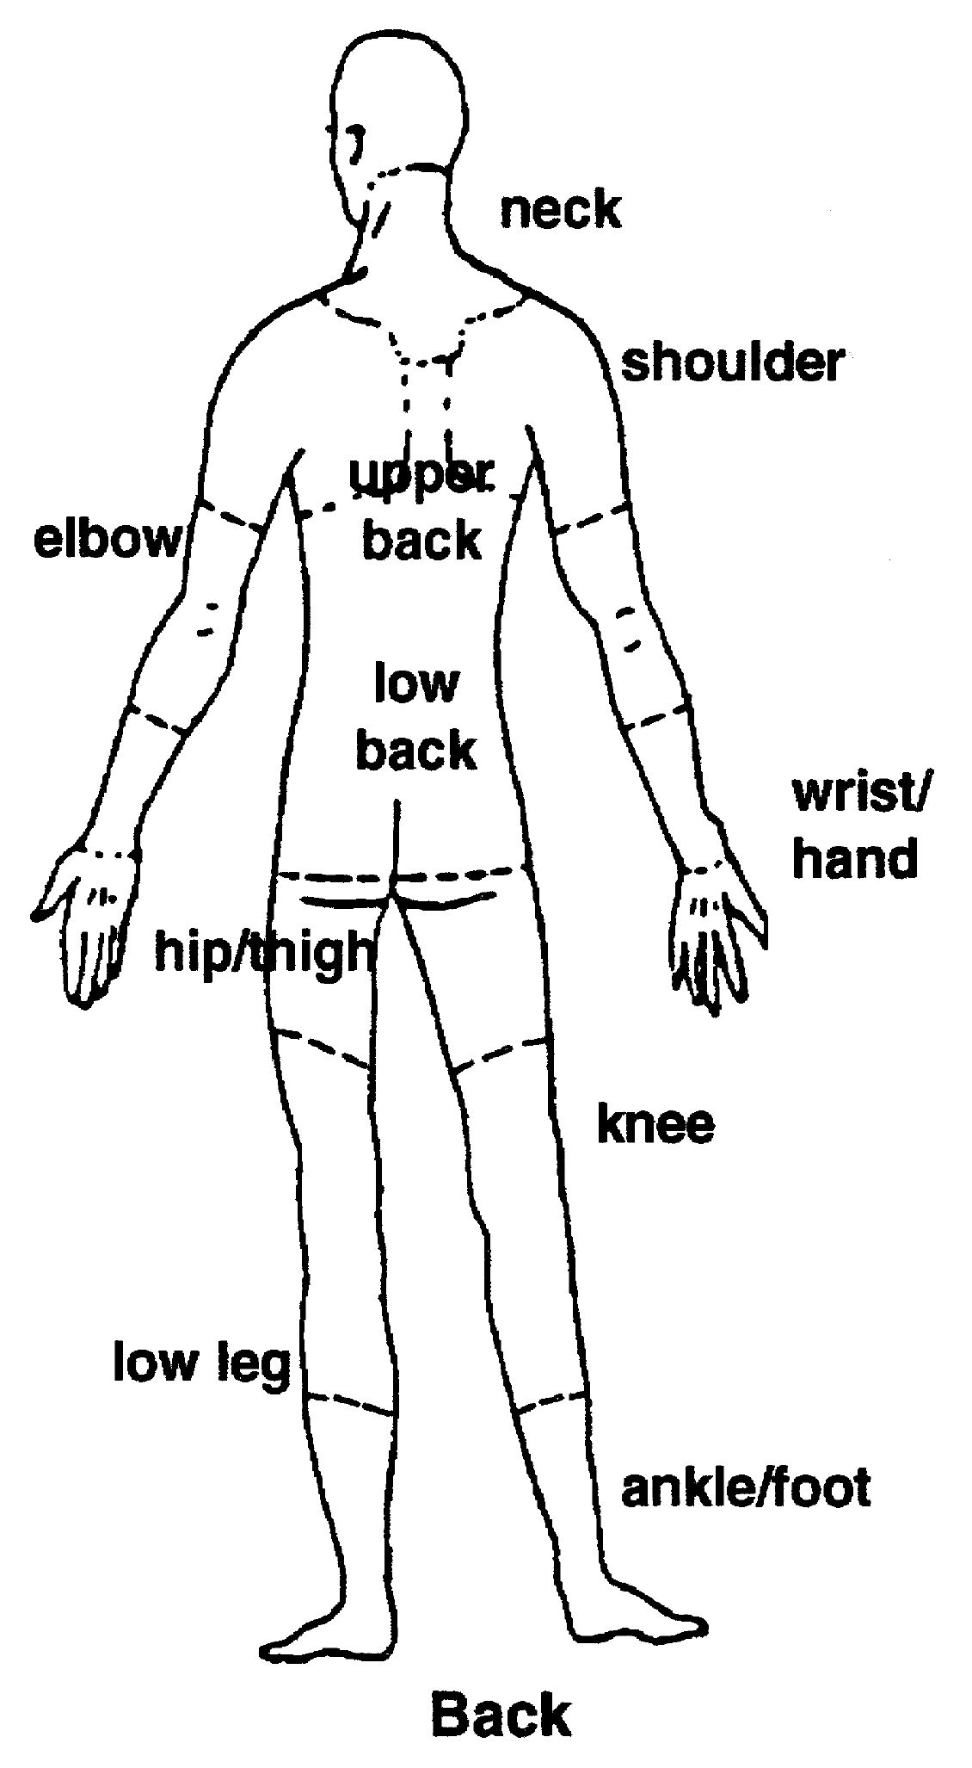
1  No effort | 2 | 3  Moderate force and speed | 4 | 5  Maximum force or speed
Awkward posture - How awkward is the person’s posture?
1  All postures neutral | 2 | 3  Moderately uncomfortable | 4 | 5  Very uncomfortable
Vibration - How much are the whole body or hand(s) being vibrated?
1  None | 2 | 3  Moderate | 4 | 5  Extreme
Duration - How long is the action performed for?
1  less than 10 minutes | 2  10-30 min | 3  30 min - 1 hour | 4  1-2 hours | 5  more than 2 hours
Repetition - How often are similar actions done
1  No repetition | 2 | 3  cycle times less than 30 sec | 4 | 5  cycle time less than 10 sec

Risk controls .

Design Control options
Eliminate, substitute, engineer

Administrative control options:

