Work Health and Safety Act 2011 (WHS Act)
Work Health and Safety Regulation (WHS Regulation

Appendix 10: Worker discomfort survey .
Provide this survey to workers for individual completion or for working through in a group setting.

Workplace name
Date
Which work tasks do you think are a problem i.e. the most likely to cause you or others in your team injury, the ones you hate doing?
Tasks:
Do you suffer from swelling, numbness, tingling, pins and needles, stiffness aches and pains in any parts of your body? (circle) |  |  |  | YES | NO
Please mark on the body diagram where you feel discomfort or pain | 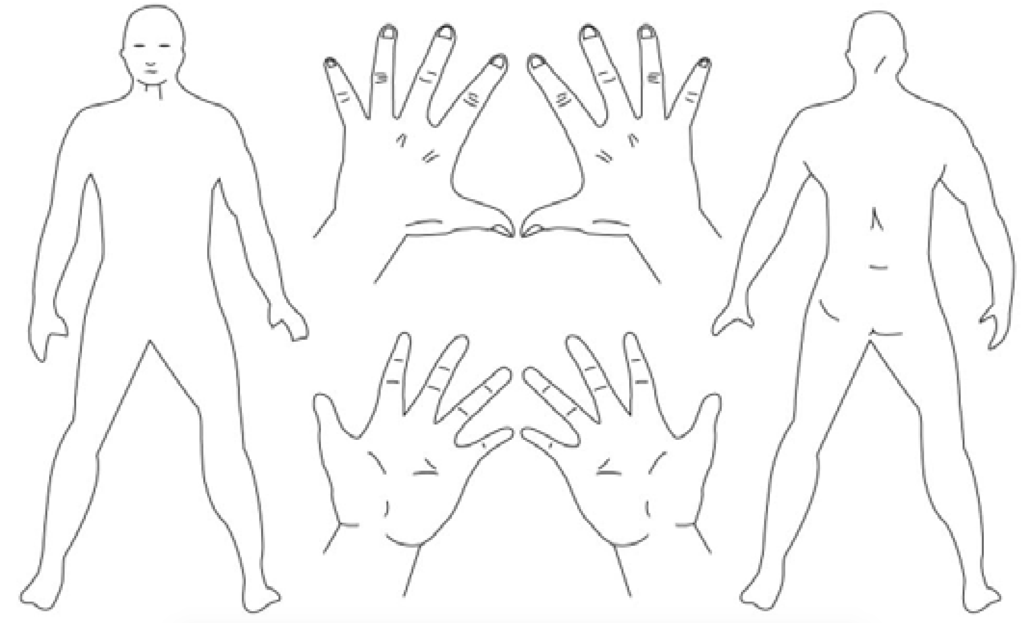
 | Rate the discomfort / pain on a scale of 1 to 5
 | 1  Slight | 2 | 3  Moderate | 4 | 5  Unbearable
What do you think caused the problem?
Do you have any improvement ideas that would reduce the risk of injury?

