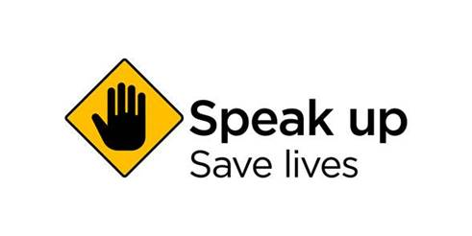

**Stop. Speak Up. Save Lives.**

Workplace safety is everyone’s responsibility, but we understand not everyone feels confident in raising unsafe work when they see it.

Workers should always raise safety issues with their boss or health and safety representative in the first instance, but when they can’t, they need another way to do so.

SafeWork NSW has developed [Speak Up](https://speakup.safework.nsw.gov.au/), a new web tool that allows anyone to quickly and confidentially raise a safety issue with just a few taps on their mobile.

Speak Up is just one of many tools that we offer to prevent workplace incidents before they happen. To ensure everyone comes home safely from work.

Speak Up is free and easy to use. You can use your mobile to upload up to three images and the location of the unsafe work. If you don’t know the address, you can simply use the GPS function.

Once an issue is logged, we will review it and take action based on the level of risk. If the user provides contact details, they will be sent a receipt of their concern via email or text.

The Speak Up web tool should not be used for reporting [legally notifiable incidents](https://www.safework.nsw.gov.au/safety-starts-here/safety-support/investigating-and-reporting-incidents/investigating-and-reporting-incidents-accodions/notifiable-incidents), such as death, serious injury or illness, or when a potentially dangerous incident occurs. These should be reported to SafeWork by calling 13 10 50.

For further tips and tools to keep you and your workers safe, visit [safework.nsw.gov.au](http://safework.nsw.gov.au/) or call 13 10 50.