NSW Government Work Health and Safety Sector Plan
Communications Toolkit

Background
The New South Wales Government sector accounts for more than 10 per cent of the NSW workforce. This is a diverse group of workers which includes nurses, teachers, fire fighters, engineers, scientists, train drivers, cleaners and administrators. Collectively, they support the infrastructure of our state and provide the services necessary for the people of NSW to grow and prosper.

The NSW Government Work Health and Safety Sector Plan renews our commitment to provide safe and healthy workplaces for all workers under our care.

The workers are those with the greatest practical experience of safety risks, and who experience the highest degree of personal risk. They’re the ones who are best placed to identify solutions to unsafe practices.

This project acknowledges that workers are the experts in what they do and are therefore best placed to identify work health and safety problems and solutions. This worker-centric consultative process empowers workers to proactively identify, assess and problem-solve healthy and safety concerns to drive work health and safety outcomes which are owned by the workers themselves.

This project is more than just a work health and safety program, it’s a cultural change program.

Timing
The project will run through to 2021/22.

Project objectives
The project aims to:
- Inform stakeholders of the Government Work Health and Safety Sector plan, its objectives and the commitment from all clusters in the NSW Government to implement the plan
- Raise awareness of the objectives of the Government Work Health and Safety Sector Plan and alignment with the Roadmap.
- Support a change in attitude towards NSW Government Work Health and Safety compliance
- Demonstrate our commitment to work health and safety
- Articulate a compelling and inspiring work health and safety vision that staff are motivated to follow

Key messages
Following are some key messages to use in communications:
- At least 1 in 10 workers in NSW works for NSW Government
- We (Government leaders) are committed to provide safe and healthy workplaces for all our workers and aim to reduce serious injuries and illnesses by 30% (from 2015/16 to 2021/22)
- We are doing this by defined objectives that embed health and safety in workplace culture, that address high risk and high harm areas, and that demonstrate our commitment to our workers
- Each and every part of NSW Government is identifying and creating their own WHS plan to improve safety and health in your workplace landscape, suggest how to address high risk areas and harms, and help NSW Government by an exemplar employer across NSW

Target audience
All cluster workers

Evaluation
Evaluate and report on the success of communications

Communication activities
This toolkit includes the following:

Posters
Asset | Details
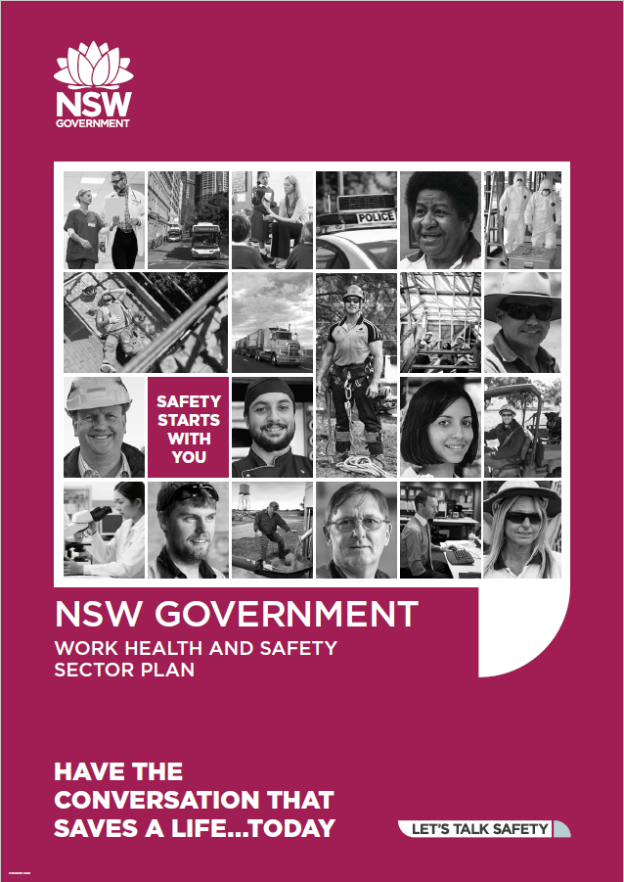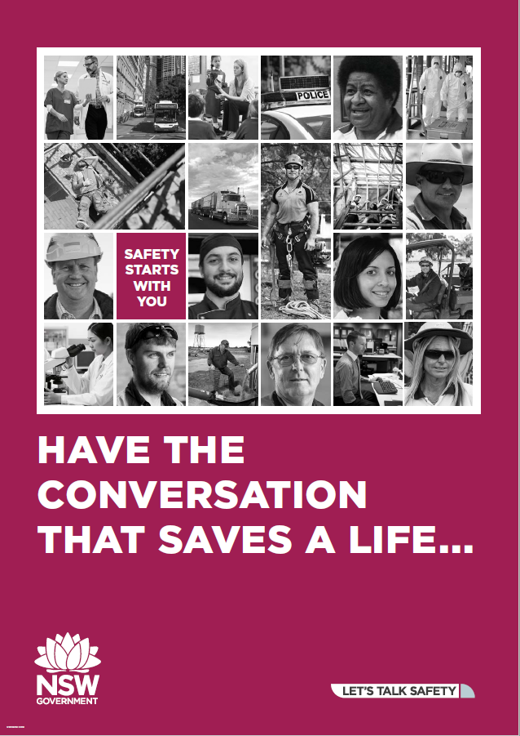  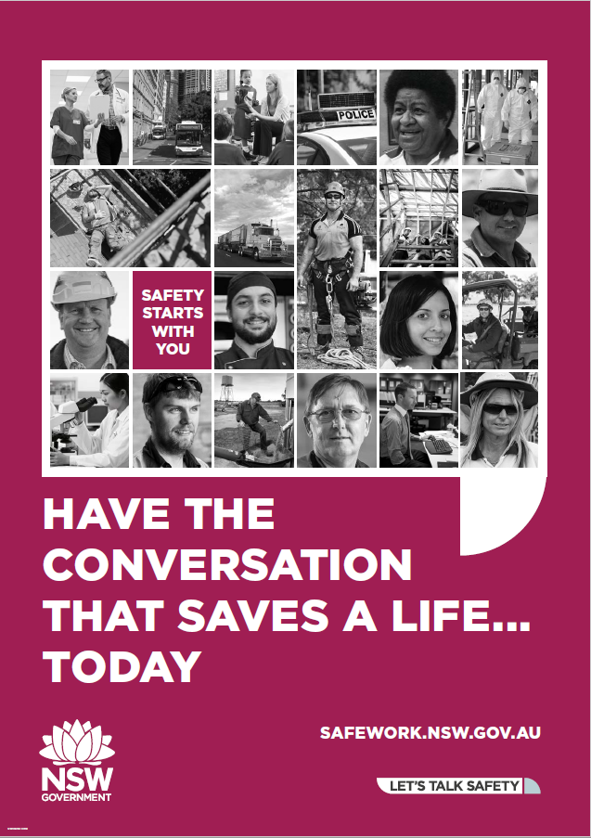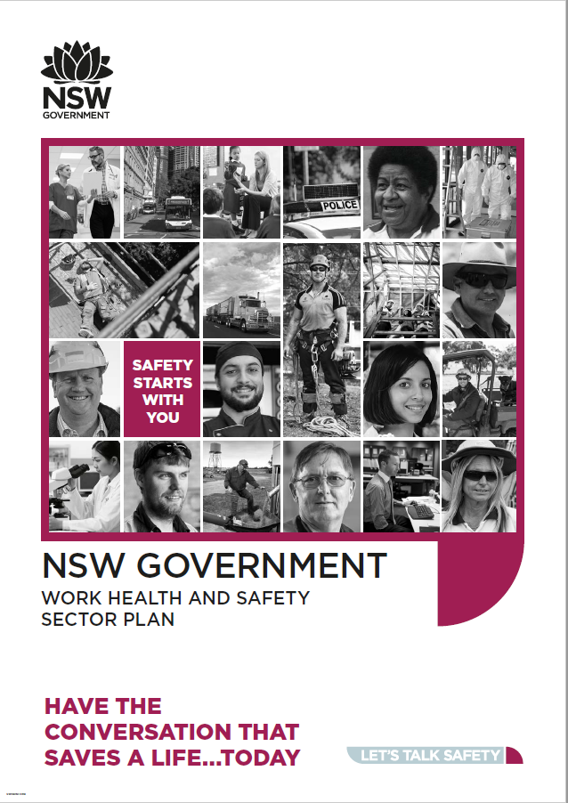 | Have the conversation that saves a life  - Print A3 or A2 posters and display them around your worksite

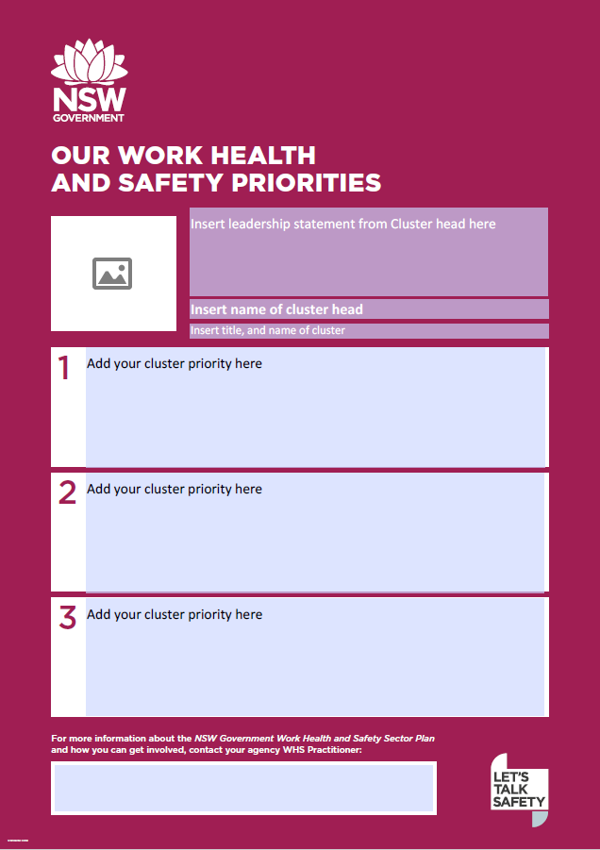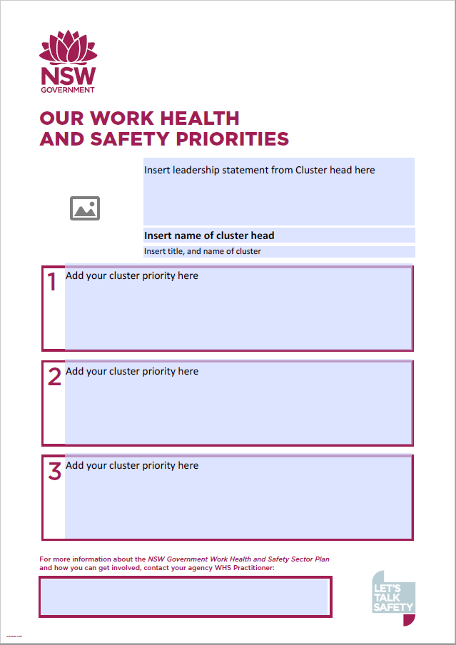  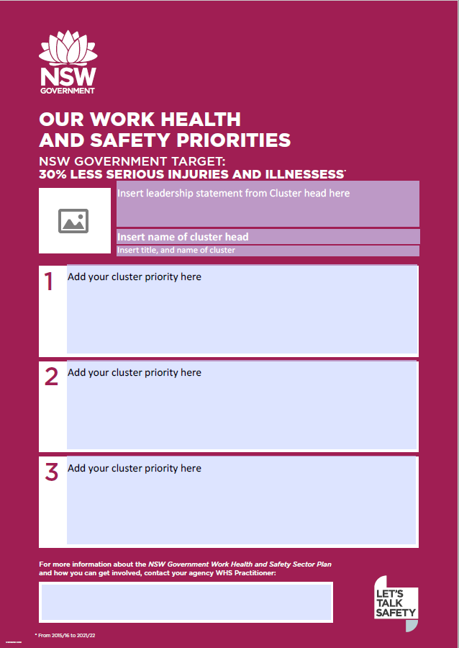 | Cluster priorities  - Add your cluster priorities as well as an image and statement from your cluster head  - Add your WHS practitioner’s contact details  - Print A3 or A2 posters and display them around your worksite

DL flyer
Asset | Details
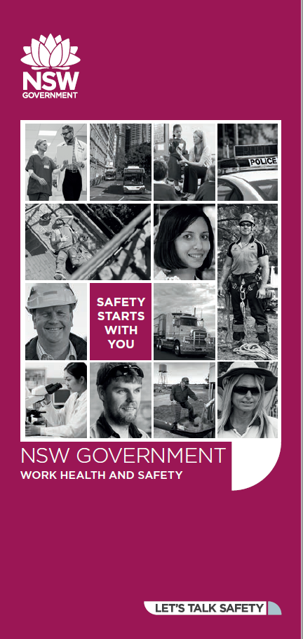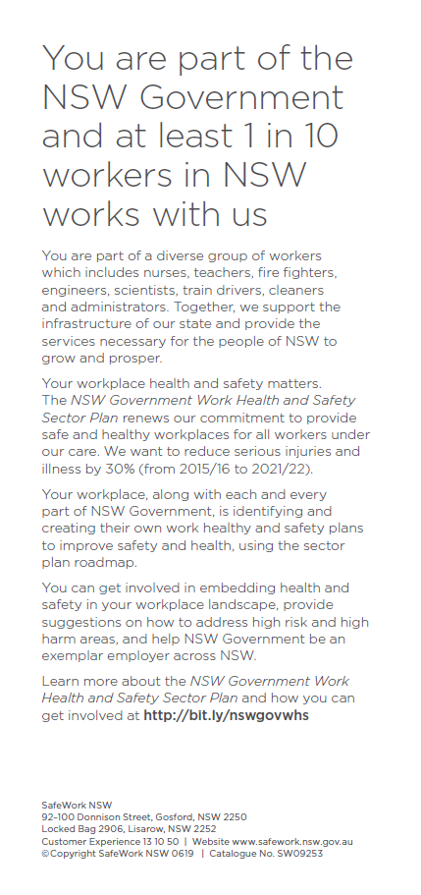 | - Print DL size  - Hand out to your workers

Plan on a page
Asset | Details
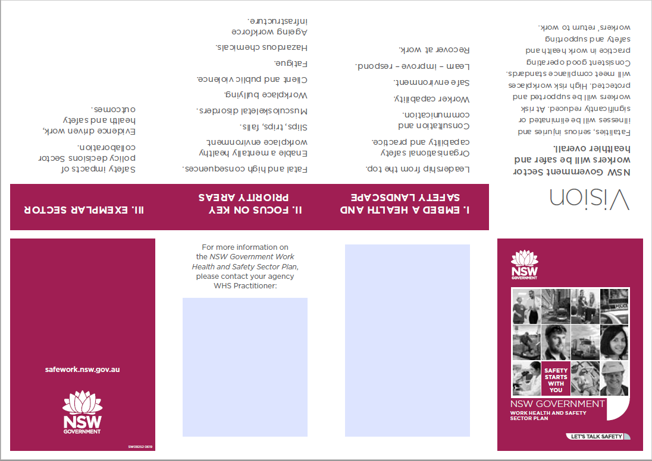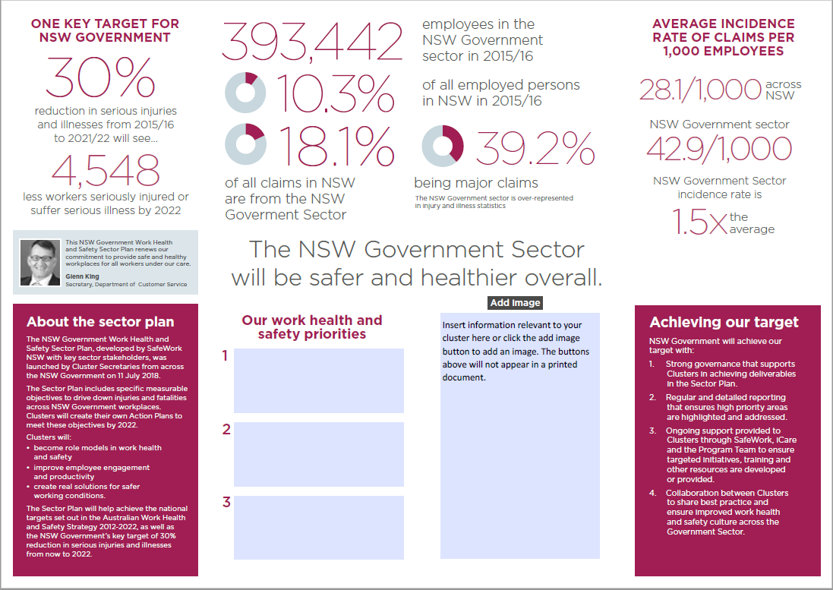 | - Add your own content in the editable boxes to tailor the content to your cluster  - Print on A4 double sided (flip on short edge) and fold into booklet  - Hand out to your workers. Workers can pin these at theur

Digital tiles and banners
Asset | Details
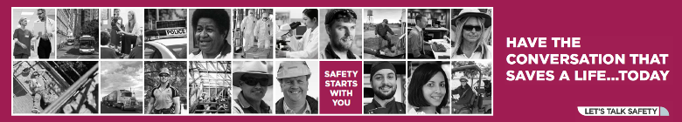  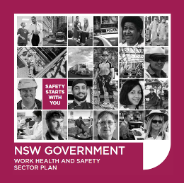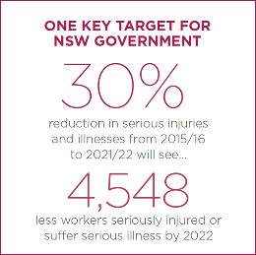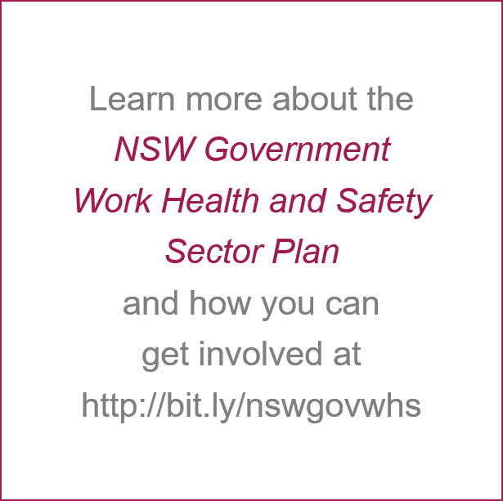  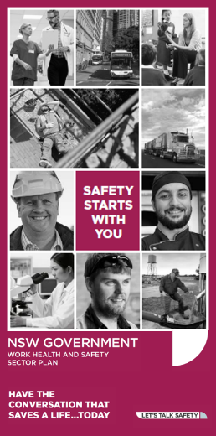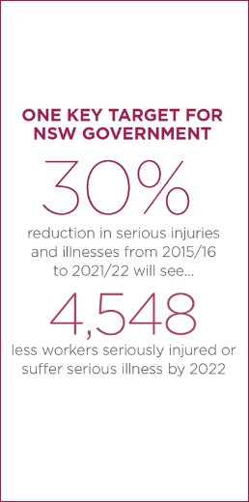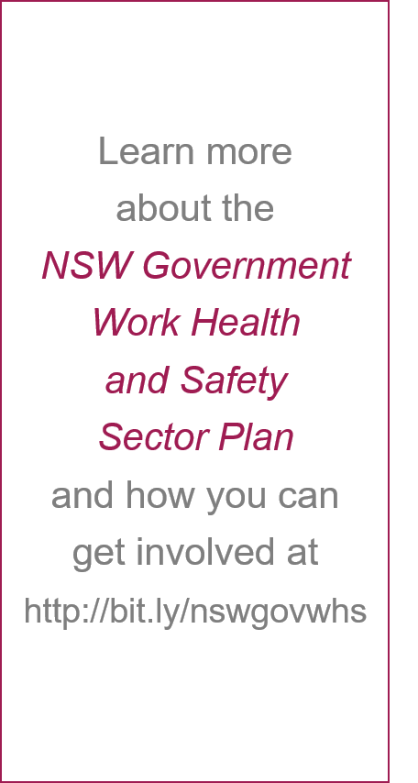 | - Display banners on your intranet linking them to your cluster’s sector plan intranet page  - Uploading and display the digital tiles on digital screens around your worksites.

Presentation
Asset | Details
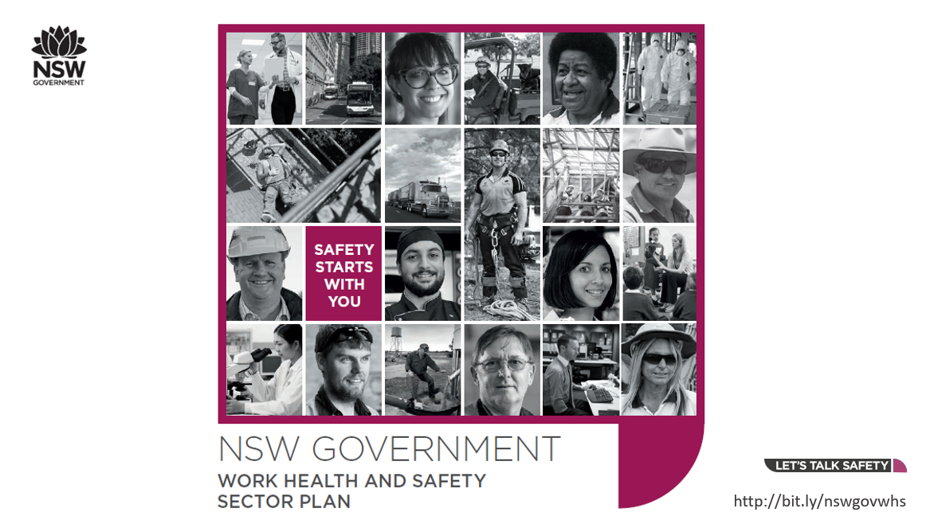 | - Share these key messages slides with people managers and ask them to communication the Sector Plan with their team and detail the cluster’s priorities and next steps  - Ask leaders to add the topic of WHS to their team meetings so they check in regularly on any issues with their team  - Hosting a morning or afternoon tea and use the opportunity to remind workers of the role they play in supporting work health and safety.

Content
Asset | Details
See below | - Include an article in your regular e-newsletter.  - Publish an online article on your intranet to share progress against the cluster’s priorities.  - Build and promote stories to celebrate wins, emphasising what was accomplished and the steps taken to achieve success.

Social Media
Asset | Details
N/A | Share posts using the internal tools available – e.g. Workplace for Facebook, Yammer etc. Use the hashtags #letstalksafety

Intranet Article/Content - (255 words)
Making the NSW Government Sector safer and healthier
At least 1 in 10 workers in NSW work for the NSW Government, that’s almost 400,000 employees. The NSW Government is over-represented in injury and illness statistics with 18.1% of claims in NSW being from the NSW Government Sector. That’s over 50,000 claims over a three-year period costing $863M and resulting in 644,470 weeks of lost in work time.
The NSW Government Work Healthy and Safety Sector Plan is the NSW Government’s five-year commitment to our workers ensuring we strive to make robust and proactive work health and safety ‘business as usual’ for all NSW government workers.
All the cluster Secretaries have joined forces with a united commitment to achieve improvements in work health and safety across the public sector Each and every part of NSW Government is identifying and creating their own WHS plan to improve safety and health in your workplace landscape, suggest how to address high risk areas and harms, and help NSW Government by an exemplar employer across NSW. Each cluster’s performance in health and safety will be tracked and reported to the Secretaries Board every six months with the aim of reducing workplace injury and illness in the public sector by 30 per cent by 2022.
Now it is up to us, as NSW government workers, to help build a healthier and safer workplace.
Learn more about the NSW Government Work Health and Safety Sector Plan and how you can get involved at SafeWork’s website or contact our WHS Practitioner [insert details].

