High Risk Construction Work Safe Work Method Statement Template
NOTE: Work must be performed in accordance with this SWMS.
This SWMS must be kept and be available for inspection until the high risk construction work to which this SWMS relates is completed.
If the SWMS is revised, all versions should be kept.
If a notifiable incident occurs in relation to the high risk construction work in this SWMS, the SWMS must be kept for at least 2 years from the date of the notifiable incident.
[PCBU Name, contact details] |  |  |  | Principal Contractor (PC) |  | [Name, contact details]
Works Manager:  Contact phone: |  |  |  | Date SWMS provided to PC:
Work activity: | [Job description] |  |  | Workplace location:
High risk construction work: | Risk of a person falling more than 2 metres (note: in some jurisdictions this is 3 metres) |  | Work on a telecommunication tower |  |  |  | Demolition of load-bearing structure
 | Likely to involve disturbing asbestos |  | Temporary load-bearing support for structural alterations or repairs |  |  |  | Work in or near a confined space
 | Work in or near a shaft or trench deeper than 1.5 m or a tunnel |  | Use of explosives |  |  |  | Work on or near pressurised gas mains or piping
 | Work on or near chemical, fuel or refrigerant lines |  | Work on or near energised electrical installations or services |  |  |  | Work in an area that may have a contaminated or flammable atmosphere
 | Tilt-up or precast concrete elements |  | Work on, in or adjacent to a road, railway, shipping lane or other traffic corridor in use by traffic other than pedestrians |  |  |  | Work in an area with movement of powered mobile plant
 | Work in areas with artificial extremes of temperature |  | Work in or near water or other liquid that involves a risk of drowning |  |  |  | Diving work
Person responsible for ensuring compliance with SWMS: |  |  |  |  | Date SWMS received:
What measures are in place to ensure compliance with the SWMS? |  | Note: How do you intend to monitor SWMS Compliance
Person responsible for reviewing SWMS control measures: |  |  |  |  | Date SWMS received by reviewer:
How will the SWMS control measures be reviewed?
Review date: |  |  |  |  | Reviewer’s signature:

What are the tasks involved? | What are the hazards and risks? | What are the control measures?
List the work tasks in a logical order. | Identify the hazards and risks that may cause harm to workers or the public. | Describe what will be done to control the risk. What will you do to make the activity as safe as possible?
Note: HRCW activities are listed in this column | Note: These hazards and risks refer to High Risk construction work as defined in Clause 291 | Keep it simple and practical – this is what you will need to monitor your compliance against.
Work in or adjacent to a road, railway, shipping lane or other traffic corridor that is in use by traffic other than pedestrians.

Movement of powered mobile plant.

Falling more than 2 metres

Temporary load-bearing support for structural
alterations or repairs

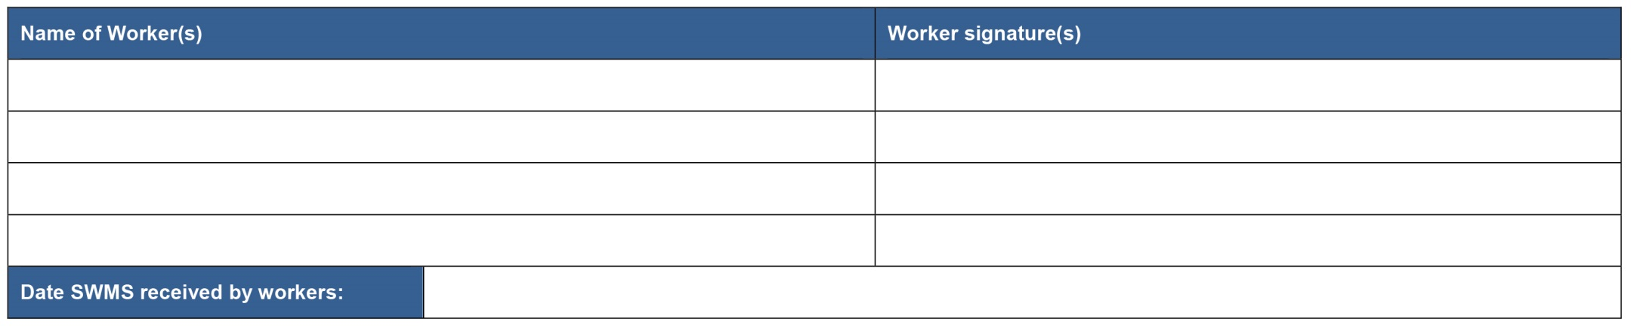
PLEASE NOTE: THE TRIAL PERIOD FOR THIS DOCUMENT HAS CONCLUDED AND IS NOW BEING REVIEWED. THE CONTROLS ARE INDICATIVE ONLY AND WILL CHANGE IN ACCORDANCE WITH SITE CONDITIONS.

